SFI 2022 – Summary Audit Report

DESCRIPTION OF THE CERTIFED ORGANIZATION

AV Group NB. Owns to Pulp mills in New Brunswick. AV Group consists of two strategically located pulp mills located in Atholville, NB and Nackawic, NB. The pulp mills which are focused on producing specialty pulp products to service the textile and paper industry. The Group is a member of the Aditya Birla Group of India. The operations in the North are found on License #1 and in the South on License #8 and Freehold lands.

The company SFI representative is Pierre Mezzetta.

AUDIT PROCESS
During the period of July 3, 2023 to July 7, 2023, underwent a surveillance audit to the Sustainable Forestry Initiative® (SFI®) 2022 Forest Management (FM) and 2022 Fiber Sourcing (FS) Standards.
The registration cycle is over five years with surveillance audits conducted annually. The audit assessed active and/or completed harvest operations through interviews with the company staff and contractors. The audit also assessed the SFI documentation and records at the company’s office including stakeholder and Indigenous people communication.
The SFI program third-party audit was undertaken by SAI Global. SAI Global is an independent third-party registrar that is accredited by the ANSI National Accreditation Board (ANAB) Standard ensuring the integrity and credibility of the audit process.

THE AUDIT TEAM
The SAI Global audit team who performed the audit consisted of Hervé Bescond, audit team leader, and Jean-François Légaré and Stéphane Audit, audit team members. The auditors are Professional Foresters and certified auditors.

REGISTRATION TYPE
Certificate Type | SFI 2022 Forest Management Standard | SFI 2022 Fiber Sourcing Standard
Single site | ☒ | ☒

MULTI-SITE / GROUP EVALUATION
☒ Not applicable. The certification is not a multi-site or group.

SFI 2022 Forest Management Standard

FOREST LAND AND MANGEMENT PLAN INCLUDED IN THE AUDIT SCOPE
Management plan | The licenses 1 and 8 management plans follow the requirements of the New Brunswick Crown Lands and Forests Act (1980). The proposal forecasts timber, vegetation community and habitat supply for 80 years.
Area of ownership | Crown Land
Major timber types | License 1 is located in Northern New Brunswick, mainly east of Saint-Quentin, and West of Bathurst. It is located in Restigouche County and comprises a total area of 425,268 hectares. 94% of this total area is classed as productive forestland (402,284 ha).  License 8 is located in western New Brunswick. It is located mainly in York County and comprises a total area of 261,825 hectares. 90% of this total area is classed as productive forestland (235,576 ha).
Management approaches | The plans objectives are for a number of values and guidelines as presented by the Department of Natural Resources (DNR). The Forest Management Agreement (FMA), the contract that allows AV Nackawic (AVN) the right to manage York License 8, stipulates that all freehold lands owned by the company must be managed in a similar fashion as Crown Land.
Long-term harvest level

SCOPE OF CERTIFICATION
Forest management activities- planning, harvesting, transportation and silviculture on the Crown Licenses 1,8 in New-Brunswick. Fiber sold under this certificate counts as 100% SFI and 100% PEFC certified forest content.

There has been no modificaiton to the scope since the last public summary audit report.

AUDIT PROCESS
During this audit, the audit team evaluated the company against the objectives listed in Table 1. The evidence of compliance observed is listed in Table 2. Both tables are found in the section Evidence of Conformity to the SFI 2022 Forest Management Standard.
A sample sites (for the field audit) were chosen from a list of active sites and sites where forest management activities occurred since the last audit. The site choice also considered activity type, and risk factors, related to the audit objectives selected for review, as well as the opportunity to verify implementation of corrective actions for previous non-conformities.

SUBSTITUTE INDICATORS
☒ Not applicable. No substitute indictors were evaluated during this audit.

COMPLAINTS
No complaints have been received.

AUDIT TIME, SITES AND ACTIVITIES AUDITED
Audit Activity | Duration in days
Off-site preparation | 1
On-site audit | 2,5
Off-site audit | 2
Field audit | 1
Sites | Activities audited
License 8 308F890 | Active harvesting
License 8 308B431 | Active harvesting
License 8 308F011 | Active harvesting
License 8 308B484 | Silviculture, Cleaning
License 1 IP | Silviculture, PCT
License 1 Mulligan | Silviculture, PCT
License 1 Berry Brook road | Active harvesting and road construction

SUMMARY OF FINDINGS
Definitions for findings can be found in Appendix 1.

Non-conformance(s) identified during this audit
☒ Not applicable. No non-conformances were identified.

Opportunities for improvement
N/A
Exceptional management practices
☒ Not applicable. No exceptional practices were identified.

Status of previous audit non-conformance(s)
☒ Not applicable. No non-conformities were raised during the previous audit.

CERTIFICATION DECISION SFI 2022 FOREST MANAGEMENT STANDARD

Surveillance Audit
Based on the results of this audit, it has been determined that the management system is effectively implemented and meets the requirements relative to the scope of registration and audit criteria.
No Major NC(s) issued | ☒
No minor NC(s) issued | ☒
For this recertification audit, a recommendation to maintain the certification is made to SAI Global

EVIDENCE OF CONFORMITY TO THE SFI 2022 FOREST MANAGEMENT STANDARD

Table 1 Objectives Audited
1.4 | Forest Management Standard Principles | ☒
Objective 1 | Forest Management Planning | ☐
Objective 2 | Forest Health and Productivity | ☒
Objective 3 | Protection and Maintenance of Water Resources | ☐
Objective 4 | Conservation of Biological Diversity | ☐
Objective 5 | Management of Visual Quality and Recreational Benefits | ☐
Objective 6 | Protection of Special Sites | ☐
Objective 7 | Efficient Use of Forest Resources | ☒
Objective 8 | Recognize and Respect Indigenous Peoples’ Rights | ☒
Objective 9 | Climate Smart Forestry | ☐
Objective 10 | Fire Resilience and Awareness | ☐
Objective 11 | Legal and Regulatory Compliance | ☒
Objective 12 | Forestry Research, Science and Technology | ☐
Objective 13 | Training and Education | ☒
Objective 14 | Community Involvement and Landowner Outreach | ☒
Objective 15 | Public Land Management Responsibilities | ☐
Objective 16 | Communications and Public Reporting | ☒
Objective 17 | Management Review and Continual Improvement | ☒

Table 2 Evidence Observed
Objective 1 Forest Management Planning
Maps / GIS inventories | ☐
Long term management plans and sustainable harvest level calculation | ☐
Timber supply review | ☐
Timber development standards | ☐
Cutting/harvesting permits | ☐
Landscape assessment | ☐
Landscape level plans | ☐
Objective 2 Forest Health and Productivity
Maps / GIS inventories | ☒
Wet/adverse weather plans or guidelines | ☒
Reforestation plans | ☒
Planting program records | ☒
Standard Operating Procedures (SOPs) for best management practices | ☒
Silviculture surveys and reports | ☒
Standards for seed use | ☒
Chemical use/spray records | ☒
Chemical applicator certification | ☒
Pre-harvest site assessments | ☒
Tree improvement reports | ☐
Harvest inspection records | ☒
Road and bridge inspection records | ☒
Pest management plan | ☐
Field review / interviews | ☒
Objective 3 Protection and Maintenance of Water Resources
Operational plans (annual, cut block level) | ☐
Standard Operating Procedures (SOPs) for best management practices | ☐
BMP monitoring records / reports | ☐
EMS and SFI field handbook | ☐
Logging agreements and/or contracts | ☐
Pre-work discussions/meeting records | ☐
Fire preparedness plan | ☐
Spill prevention and response plan | ☐
Wet weather procedures | ☐
Field review / interviews | ☐
Objective 4 Conservation of Biological Diversity
Maps / GIS inventories | ☐
Impact assessments | ☐
Operational plans (annual, cut block level) | ☐
Wood producer training programs | ☐
NatureServe queries | ☐
Research support records | ☐
Observation / survey forms and records | ☐
Field review / interviews | ☐
Objective 5 Management of Visual Quality and Recreational Benefits
Visual assessments | ☐
Cut block size calculations | ☐
Green-up records | ☐
Free growing records | ☐
Field review / interviews | ☐
Recreational assessment | ☐
Recreation plans | ☐
Field review / interviews | ☐
Objective 6 Protection of Special Sites
Maps / GIS inventories | ☐
Consultation on special sites | ☐
Field review / interviews | ☐
Objective 7 Efficient Use of Forest Resources
Utilization records | ☒
Field review / interviews | ☒
Objective 8 Recognize and Respect Indigenous Peoples’ Rights
Maps / GIS inventories | ☒
Agreements and communications with Indigenous communities | ☒
Written policies | ☒
Standard Operating Procedures (SOPs) for best management practices | ☒
Field review / interviews | ☒
Objective 9 Climate Smart Forestry
Climate change risk assessment | ☐
Climate adaptation plan | ☐
Reforestation plans | ☐
Planting program records | ☐
Standard Operating Procedures (SOPs) for best management practices | ☐
Silviculture surveys and reports | ☐
SFI annual progress report | ☐
Objective 10 Fire Resilience and Awareness
Wildfire impact risk assessment | ☐
Standard Operating Procedures (SOPs) for best management practices | ☐
Fire preparedness plan / fire prevention program | ☐
Fire management awareness program | ☐
Objective 11 Legal and Regulatory Compliance
Laws, legislation, regulations records | ☒
Regulatory action information | ☒
Corrective action logs | ☒
Monitoring of legal requirements | ☒
Social policy | ☒
Health and safety manual and/or employee policy manual | ☒
Objective 12 Forestry Research, Science and Technology
Support for research and science | ☐
Research and discussion papers | ☐
Communication on research / implementation of research | ☐
Research knowledge transfer participation / communication | ☐
Objective 13 Training and Education
SFI policy / written policies | ☒
Roles and responsibilities documents | ☒
Training agenda | ☒
Training records (staff and contractors) | ☒
Written agreements / contracts for the use of qualified logging professionals | ☒
Wood producer information package | ☒
QLP continuing education criteria and delivery mechanisms | ☒
Objective 14 Community Involvement and Landowner Outreach
SFI Annual Report | ☒
SFI and company websites | ☒
SFI brochure | ☒
SFI Implementation Committee (participation/support) | ☒
Voluntary market-based incentive program information / participation | ☐
Education/community involvement records | ☐
SFI Implementation Committee non-conformance process information | ☒
Objective 15 Public Land Management Responsibilities
Multi-licensee and/or government meeting minutes | ☐
Stakeholder communication | ☐
Objective 16 Communications and Public Reporting
Summary audit report posting in SFI database | ☒
Current and past SFI Annual Progress Report and submission information | ☒
SFI Annual Progress Report data summary records | ☒
Objective 17 Management Review and Continual Improvement
Internal audit records | ☒
Annual management review records | ☒
 | ☐
 | ☐
 | ☐
 | ☐
 | ☐
 | ☐

SFI 2022 Fiber Sourcing Standard

CERTIFIED ORGANIZATION’S FIBER PROCUREMENT AND/OR MANUFACTURING OPERATIONS
Manufacturing operations | AV Group NB Inc. owns two pulp mills located in Atholville, NB and Nackawic, NB which are focused on producing specialty pulp products to service the textile and paper industry. The Group is a member of the Aditya Birla Group of India
Fiber sourcing program | The fiber sourcing program of the company applies to sourcing of round wood in New Brunswick, Quebec and Maine
Purchased stumpage | The organization has a purchased stumpage program.
Verifiable monitoring system | A system is implemented. This system includes a monitoring program and an internal audit program. The implementation of the system has been reviewed during the field visit
Procurement area | New Brunswick, Quebec and Maine

CERTIFIED ORGANIZATION’S ASSESSMENT FOR FORESTS WITH EXCEPTIONAL CONSERVATION VALUES
An assessment and mapping of Exceptional Conservation Value has been implanted and documented in a report on forests of high conservation value(HCV). This report describes the method for assessing and identifying HCV in accordance with the assessment process.

SCOPE OF CERTIFICATION
Sourcing fiber from New Brunswick, Quebec and Maine The Appendix 1: Rules for Use of SFI Certified Sourcing Label is not covered by the scope of this certificate.
There has been no modificaiton to the scope since the last public summary report.

AUDIT PROCESS
During this audit, the audit team evaluated the company against the objectives listed in Table 1. The evidence of compliance observed is listed in Table 2. Both tables are found in the section Evidence of Conformity to the SFI 2022 Fiber Sourcing Standard.
A sample of field review sites were chosen from a list of active sites and sites where activities were completed since the last audit. The site choice also considered activity type, and risk factors, related to the audit objectives selected for review, as well as the opportunity to verify implementation of corrective actions for previous non-conformities.

SUBSTITUTE INDICATORS
☒ Not applicable. No substitute indictors were evaluated during this audit.

COMPLAINTS
No complaints have been received.

AUDIT TIME, SITES AND ACTIVITIES AUDITED
Audit Activity | Duration in days
Off-site preparation | 0
On-site audit | 0,5
Off-site audit | 1
Field audit | 0,5
Sites | Activities audited
North Shore Forest Products Marketing Board Site 1 | Completed Harvesting
North Shore Forest Products Marketing Board Site 2 | Completed Harvesting
North Shore Forest Products Marketing Board Site 3 | Active harvesting

SUMMARY OF FINDINGS
Definitions for findings can be found in Appendix 1.

Non-conformance(s) identified during this audit
☒ Not applicable. No non-conformances were identified.

Opportunities for improvement
☒ Not applicable. No OFIs were identified.

Exceptional management practices
☒ Not applicable. No exceptional practices were identified.

Status of previous audit non-conformance(s)
☒ Not applicable. No non-conformities were raised during the previous audit.

CERTIFICATION DECISION SFI 2022 FIBER SOURCING STANDARD

Surveillance Audit
Based on the results of this audit to the, it has been determined that the management system is effectively implemented and meets the requirements relative to the scope of registration and audit criteria.
No Major NC(s) issued | ☒
No minor NC(s) issued | ☒
For this recertification audit, a recommendation to maintain the certification is made to SAI Global

EVIDENCE OF CONFORMITY TO SFI 2022 FIBER SOURCING STANDARD

Table 1 Objectives Audited
1.4 | Fiber Sourcing Standard Principles | ☒
Objective 1 | Biodiversity in Fiber Sourcing | ☐
Objective 2 | Adherence to Best Management Practices | ☒
Objective 3 | Use of Qualified Resource and Qualified Logging Professionals and Certified Logging Companies | ☐
Objective 4 | Legal and Regulatory Compliance | ☒
Objective 5 | Forestry Research, Science, and Technology | ☐
Objective 6 | Training and Education | ☐
Objective 7 | Community Involvement and Landowner Outreach | ☒
Objective 8 | Public Land Management Responsibilities | ☐
Objective 9 | Communications and Public Reporting | ☒
Objective 10 | Management Review and Continual Improvement | ☒
Objective 11 | Avoid Controversial Sources | ☒
Table 2 Evidence Observed

Objective 1 Biodiversity in Fiber Sourcing
Program for conservation of biodiversity | ☐
Forest With Exceptional Conservation Value Assessment | ☐
Program to address Forests with Exceptional Conservation Value | ☐
Objective 2 Adherence to Best Management Practices
Agreements / contracts for use of best management practices | ☒
Wet/adverse weather plans or guidelines | ☒
Fiber Sourcing policies | ☒
BMP monitoring records / evaluation / use | ☒
 | ☐
Objective 3 Use of Qualified Resource and Qualified Logging Professionals and Certified Logging Companies
Promotion of qualified logging professionals | ☐
List of qualified logging professionals | ☐
Agreements / contracts for use of qualified logging professionals | ☐
Objective 4 Legal and Regulatory Compliance
Laws, legislation, regulations records | ☒
Regulatory action information | ☒
Corrective action logs | ☒
Monitoring of legal requirements | ☒
Social policy | ☒
Health and safety manual and/or employee policy manual | ☒
Objective 5 Forestry Research, Science, and Technology
Support for research and science | ☐
Research and discussion papers | ☐
Communication on research / implementation of research | ☐
Research knowledge transfer participation / communication | ☐
Climate model monitoring information | ☐
Objective 6 Training and Education
SFI policy / written policies | ☐
Roles and responsibilities documents | ☐
Training agenda | ☐
Training records (staff and contractors) | ☐
QLP continuing education criteria and delivery mechanisms | ☐
Objective 7 Community Involvement and Landowner Outreach
SFI Annual Report | ☒
SFI and company websites | ☒
SFI brochure | ☒
SFI Implementation Committee (participation/support) | ☒
Voluntary market-based incentive program information / participation | ☐
Outreach to forest landowners regarding certification | ☐
Education/community involvement records | ☐
SFI Implementation Committee non-conformance process information | ☒
Objective 8 Public Land Management Responsibilities
Multi-licensee and/or government meeting minutes | ☐
Stakeholder communication | ☐
Objective 9 Communications and Public Reporting | ☐
Summary audit report posting in SFI database | ☒
Current and past SFI Annual Progress Report and submission information | ☒
SFI Annual Progress Report data summary records | ☒
Objective 10 Management Review and Continual Improvement
Internal audit records | ☒
Annual management review records | ☒
Objective 11 Avoid Controversial Sources
Due diligence system | ☒
Risk assessment | ☒
Complaint procedure | ☒
Risk mitigation measures | ☒
 | ☐
 | ☐
 | ☐
 | ☐

Appendix 1: Definitions and Sampling Approach

DEFINITIONS

Major Non-Conformances
Pervasive or critical to the achievement of the SFI objectives
All major non-conformances require an action plan to be implemented by the auditee within 90 days of an initial/Recertification audit or certification cannot be achieved. During a surveillance audit, an unresolved major nonconformity will lead to the suspension of the certificate.

Minor Non-Conformances
Isolated incidents that are non-critical but must be addressed before the next surveillance audit to maintain compliance to the SFI standard. Non resolved minor non-conformance will be escalated to a major non-conformance.

Opportunity for Improvement
Are not non-conformances but are comments on specific areas where improvements can be made.

Exceptional Practices
Creative and unusual management practice worth mentioning.

MULTI-SITE / GROUP SAMPLING APPROACH
Where the multi-site / group organization maintains an internal audit program, which has been determined to be reliable, the SAI Global sampling approach is as follows:  n = number of sites:  - √(n) for initial certification audits  - 0.6 √(n) for surveillance audits  - 0.8 √(n) for re-registration audits  The central office function is audited annually. | Where the multi-site / group organization did not maintain its internal audit program, the SAI Global sampling approach is as follows:  n = number of sites:  √(n)  The central office function is audited annually.

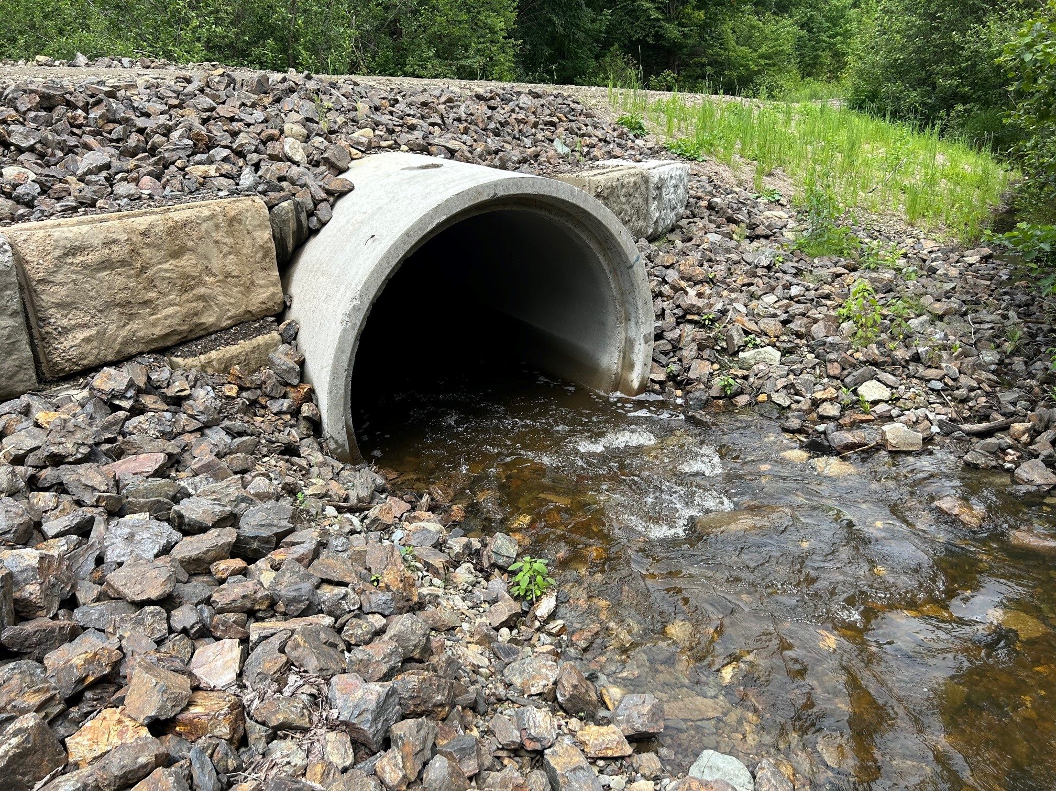
SAI Global certifies forest companies to ISO 14001, SFI Forest Management, SFI Chain of Custody, SFI Fiber Sourcing, SFI Certified Sourcing, PEFC Chain of Custody, FSC® Forest Management, and FSC® Chain of Custody.
The group, led by Sylvain Frappier, Global programme manager - Forestry, consists of a highly qualified team of professional foresters, technical and industry experts.
Contact SAI Global Assurance for more information.
Company Contact  Pierre Mezzetta  AV Group NB Inc  103 Pinder Road Nackawic, NB E6G 1W4  Pierre.mezetta@avg.adityabirla.com  (506) 260-6137 | This report may only be reproduced by the intended client, with the express consent of SAI Global. Information in this issue is of a general nature with respect to audit findings and is not intended to be acted upon without appropriate professional advice.

